**Report about best devices & OS & programming languages & database and applications.**

**System Name:**

1. **Devices**

**Pc windows 10**

**Moble android ,ios**

**Because popular devices and easy to use and support its**

1. **Operating Systems**

**android**

**ios**

**window**

**because its easy to use and popular Operating Systems and support its**

1. **Programming Language**

**C# in backend**

**Because popular language to create web app and to use** AspNetCore **(MVC)**

1. **Database**

**Sql to use arrangement data in tables**

**Mysql has big memory but no arrangement**

1. **Applications**

**Visual studio to use library** AspNetCore **(MVC)**

**Sql server managment studio to use arragment my database**

**In tables**

**Design of an integrated system (Class diagram)**

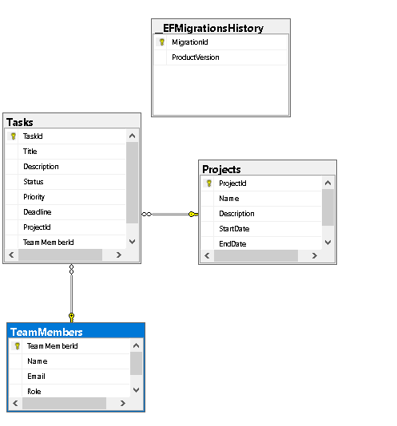

**Testing**

|  |  |  |  |  |  |  |
| --- | --- | --- | --- | --- | --- | --- |
| **Test case ID** | **Test case description** | **Test Steps** | **Test Data** | **Expected Result** | **Actual Result** | **Pass/Fail** |
| 1 | Projects controller:index view projects | When run write in url Projects/index |  | View projects | View projects | Pass |
| 2 | Projects controller:index view projects with his tasks |  |  |  |  |  |
| 2 |  | When run write in url Projects/index |  | View projects  With his tasks | View projects  With his tasks | Pass |
| 3 | Projects controller:Create projects | Click in button create | Id=4  Name=p4  Description=ctreate app about resturant  StartDate=2025-04-16  EndDate=2025-06-18 | Add project and show  In index | Add project | Pass |
| 4 | Projects controller:Edit projects | Click in button Edit | Name=p5  Description=ctreate app about resturant  StartDate=2025-04-16  EndDate=2025-06-18 | Edit project and show  In index | Edit project | Pass |
| 5 | Projects controller:Delete projects | Click in button Delete |  | Delete project  From index | Delete project | pass |
| 6 | tasks controller:edit status projects | Edit project  status | Status=in progress | Edit project  status | Edit project  status | Pass |
| 7 | Teammember controller:index view teammembers | When run write in url Teammember /index |  | View  Teammember | View  Teammember | Pass |
| 8 | Projects controller:Edit Teammember |  | TeamMemberId=5  Name=t5  [Email=t5@gmail.com](mailto:Email=t5@gmail.com)  Role=IT | Edit Teammember and show  In index | Edit Teammember | Pass |
|  |  |  |  |  |  |  |
|  |  |  |  |  |  |  |